Elastic Load Balancing (ELB) automatically distributes incoming application traffic across multiple targets and virtual appliances in one or more Availability Zones (AZs).
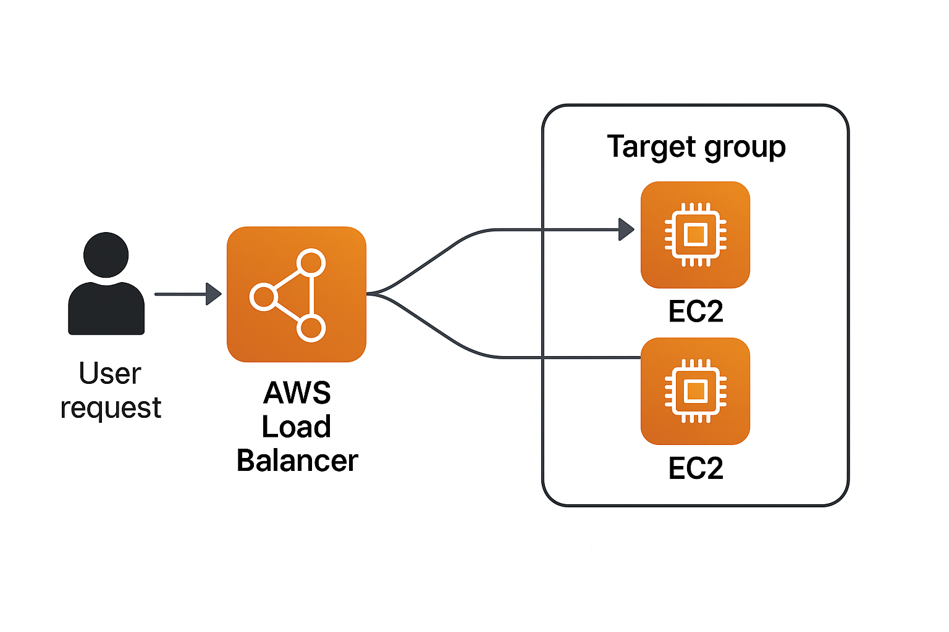

#!/bin/bash
yes | sudo apt update
yes | sudo apt install apache2 -y

HOSTNAME=$(hostname)
IP_ADDRESS=$(hostname -I | awk '{print $1}')
echo "<h1>IP Address of this server is</h1><p><strong>$IP_ADDRESS</strong></p>" | sudo tee /var/www/html/index.html
sudo systemctl restart apache2

